Project name |  | Confidentiality level
DBMS Project |  | For Recipients’ Reference Only
Project ID | Version | Document code

DBMS Project Planning

15301002 程 辰
15301009 倪施杰



Copyright © Ruankosoft Technologies(Shenzhen), Co., Ltd.
. All Rights Reserved
Revision Record
Date | Revision Version | CR ID /Defect ID | Sec No. | Change Description | Author

Content
1. Project Introduction 4
2. Deliverables and Acceptance Criteria 4
3. WBS (Work Breakdown Structure) 4
4. Project Gantt Chart 5

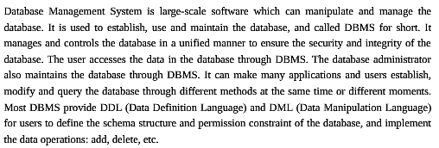
Project Introduction

Deliverables and Acceptance Criteria
S.No. | Deliverable
01 | Project start report
02 | Project planning (Optional)
03 | Software requirement specification (Optional)
04 | System design specification (Optional)
05 | Final project code
06 | Project closure summary report
07 | Project user’s manual

WBS (Work Breakdown Structure)
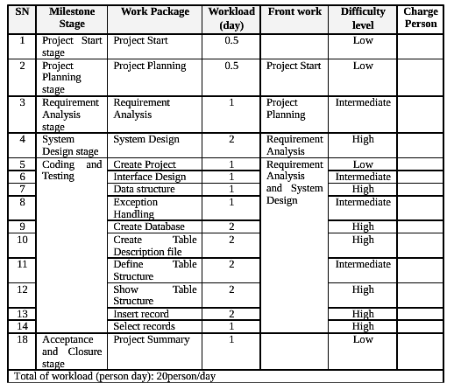

Project Gantt Chart
